**Introduction to C# and Unity API**

**LAB # 4**



**Fall 2024**

**CSE-411L Intro to Game Development Lab**

Submitted by: **Ali Asghar**

Registration No.: **21PWCSE2059**

Class Section: **A**

“On my honor, as student of University of Engineering and Technology, I have neither given nor received unauthorized assistance on this academic work.”

Submitted to:

**Engr. Abdullah Hamid**

Date:

**21st December 2024**

**Department of Computer Systems Engineering**

**University of Engineering and Technology, Peshawar**

**Objective:**

In this lab we will explore the Unity API and Basic C# Code.

**Tasks:**

- Open/create a Unity scene

- Create 3 cubes

- Color each cube differently

- Apply 3 different scripts on each cube with the following logic

- First cube shall display “Hello” on console and constantly rotate in vector3.up direction

- Second cube shall display “World” on console and start to move in vector3.forward direction and after covering some distance it should stop and comeback to its original position

- Third cube shall display “!” on the console and should increase its scale to 5 and then back to 1 and should constantly keep on increasing and decreasing scale.

**Code:**

**MyTranslation class**

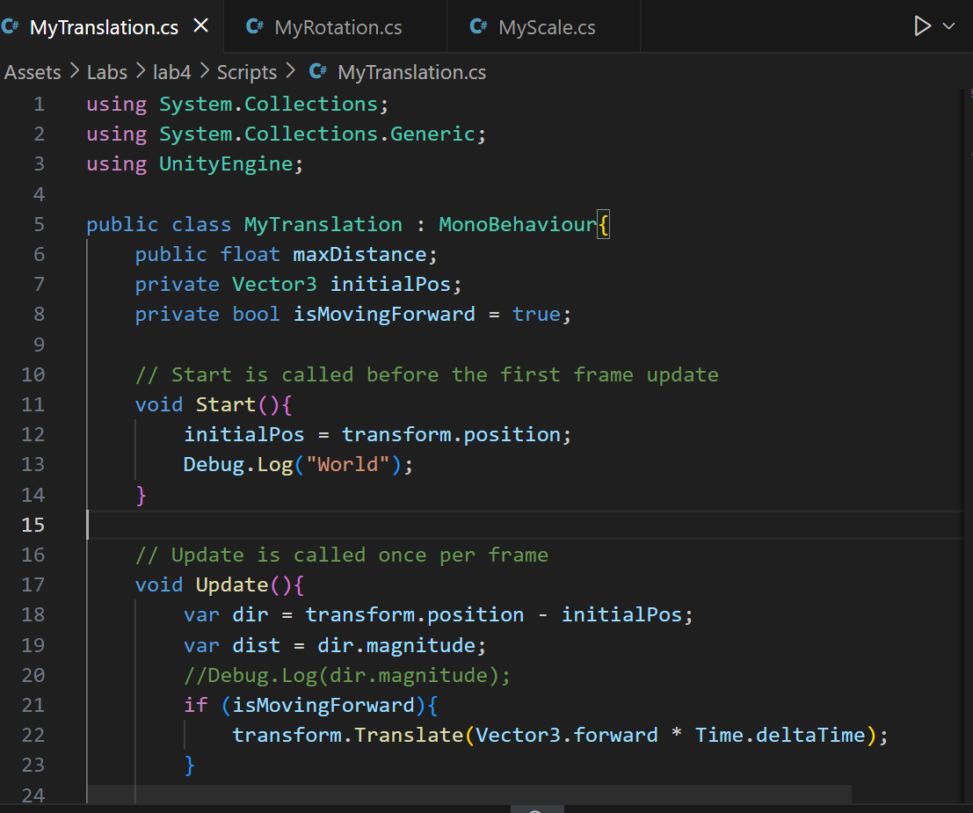

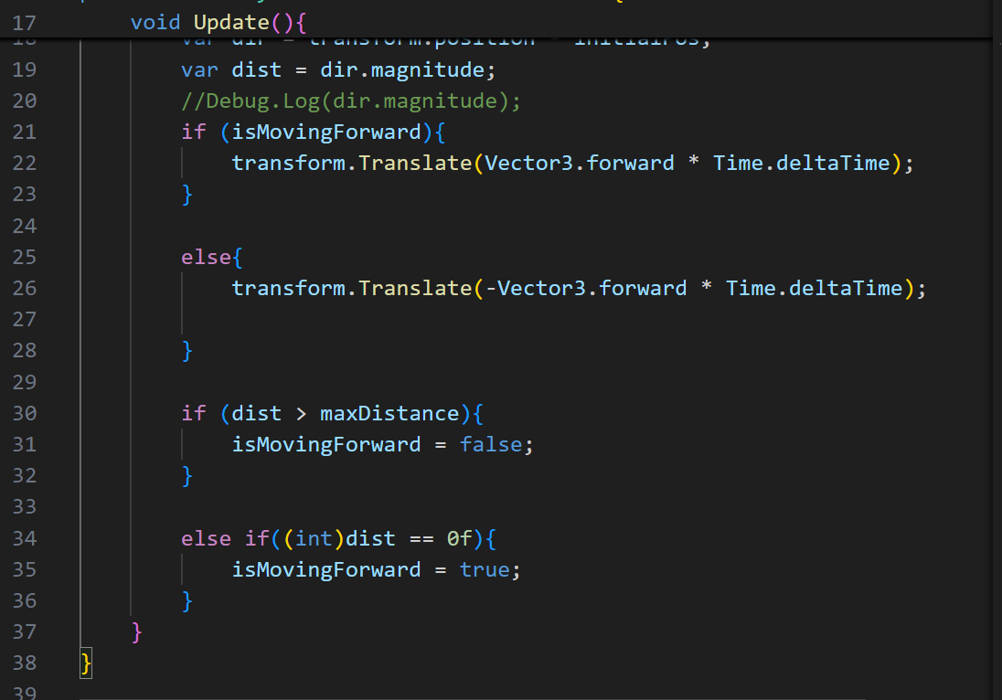

**MyRotation class**

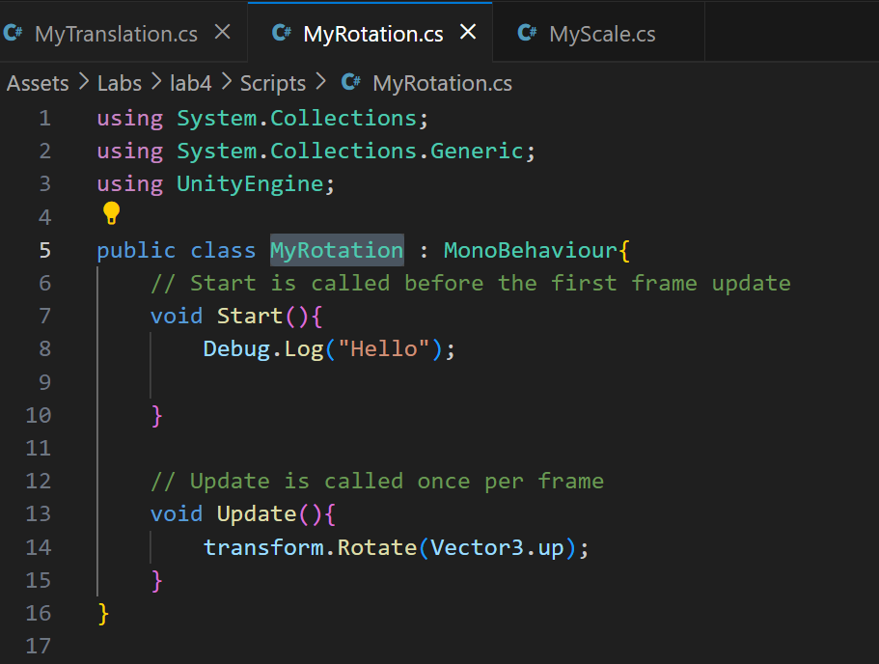

**MyScale class**

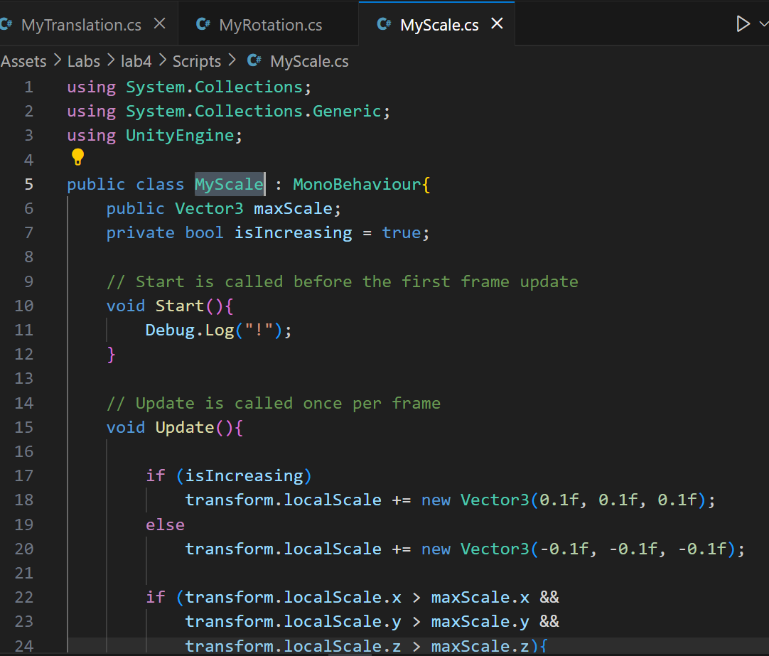

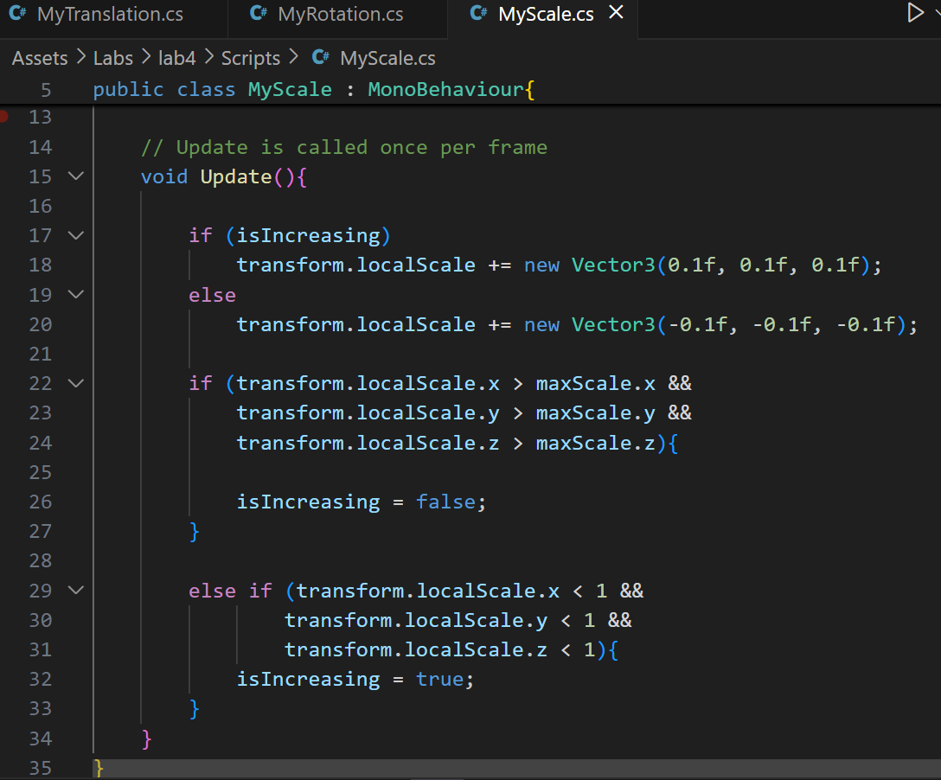

**Output:**

